NOTES 2A.2- Graphing Absolute Value Inequalities

Remember that inequalities have a set of values that represent the solution. This means that when we graph them, we must shade a region of the graph that represents these inequality solution sets.

Example 1: Provide a verbal description of the transformed inequality, graph the inequality.

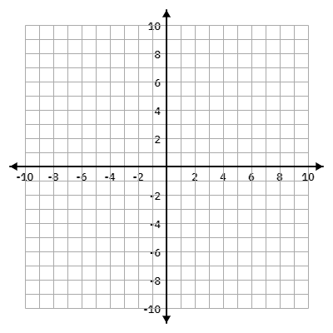
$y<-\left|x+1\right|-3$

Example 2: Provide a verbal description of the transformed inequality, graph the inequality.

$y>\left|2x-12\right|-5$


Example 3: Provide a verbal description of the transformed inequality, graph the inequality.

$y≤\left|4x+6\right|-2$


Example 4: Provide a verbal description of the transformed inequality, graph the inequality.

$y≥-\frac{1}{2}\left|x-3\right|+2$


